Project Report
Author: Shahab khan
Date: 27/06/2025
Roll No: 221396
Department: Computer Science
Section: “B”
Semester: 6
Tools Used: Python, yFinance, pandas, matplotlib, seaborn, statsmodels, scikit-learn

Project Title:
“Time Series Forecasting of Ethereum (ETH/USD) Prices Using ARIMA”

Project Overview
This project analyzes the historical price data of Ethereum (ETH) and performs time series forecasting using the ARIMA (AutoRegressive Integrated Moving Average) model. The aim is to predict short-term future prices and evaluate the model's forecasting performance using statistical error metrics.

Methodology

1. Data Collection & Preparation
- Source: Yahoo Finance via the yfinance Python package.
- Symbol: ETH-USD
- Time Period: January 1, 2020 to June 27, 2025
- Frequency: Daily (1d)
- Features Used: Open, High, Low, Close, Volume
- Preprocessing:
  - Renamed columns for simplicity.
  - Set Date as the time-series index.

2. Exploratory Data Analysis
- Visualized closing price trends.
- Detected and handled missing values (if any).
- Applied rolling statistics (mean, standard deviation) to observe stationarity.
- Used ADF (Augmented Dickey-Fuller) test to confirm stationarity requirement for ARIMA.

3. Autocorrelation Analysis
- Used ACF (AutoCorrelation Function) and PACF (Partial ACF) plots to identify the p and q parameters for ARIMA.

4. Modeling with ARIMA
- Applied ARIMA on the closing price series.
- Model hyperparameters: ARIMA(p, d, q), chosen based on ACF/PACF and stationarity.
- Trained the model and forecasted ETH prices on test data.

5. Model Evaluation
- Compared predicted values vs actual values.
- Evaluation Metrics:
  - RMSE (Root Mean Squared Error)
  - MAPE (Mean Absolute Percentage Error)
- Plotted actual vs predicted closing prices for visual validation.

Results Summary
- ARIMA provided reasonable short-term forecasts for ETH prices.
- Visual alignment between actual and predicted values confirmed that the model captured the trend effectively.
- The MAPE and RMSE values were within an acceptable range for a volatile asset like cryptocurrency.
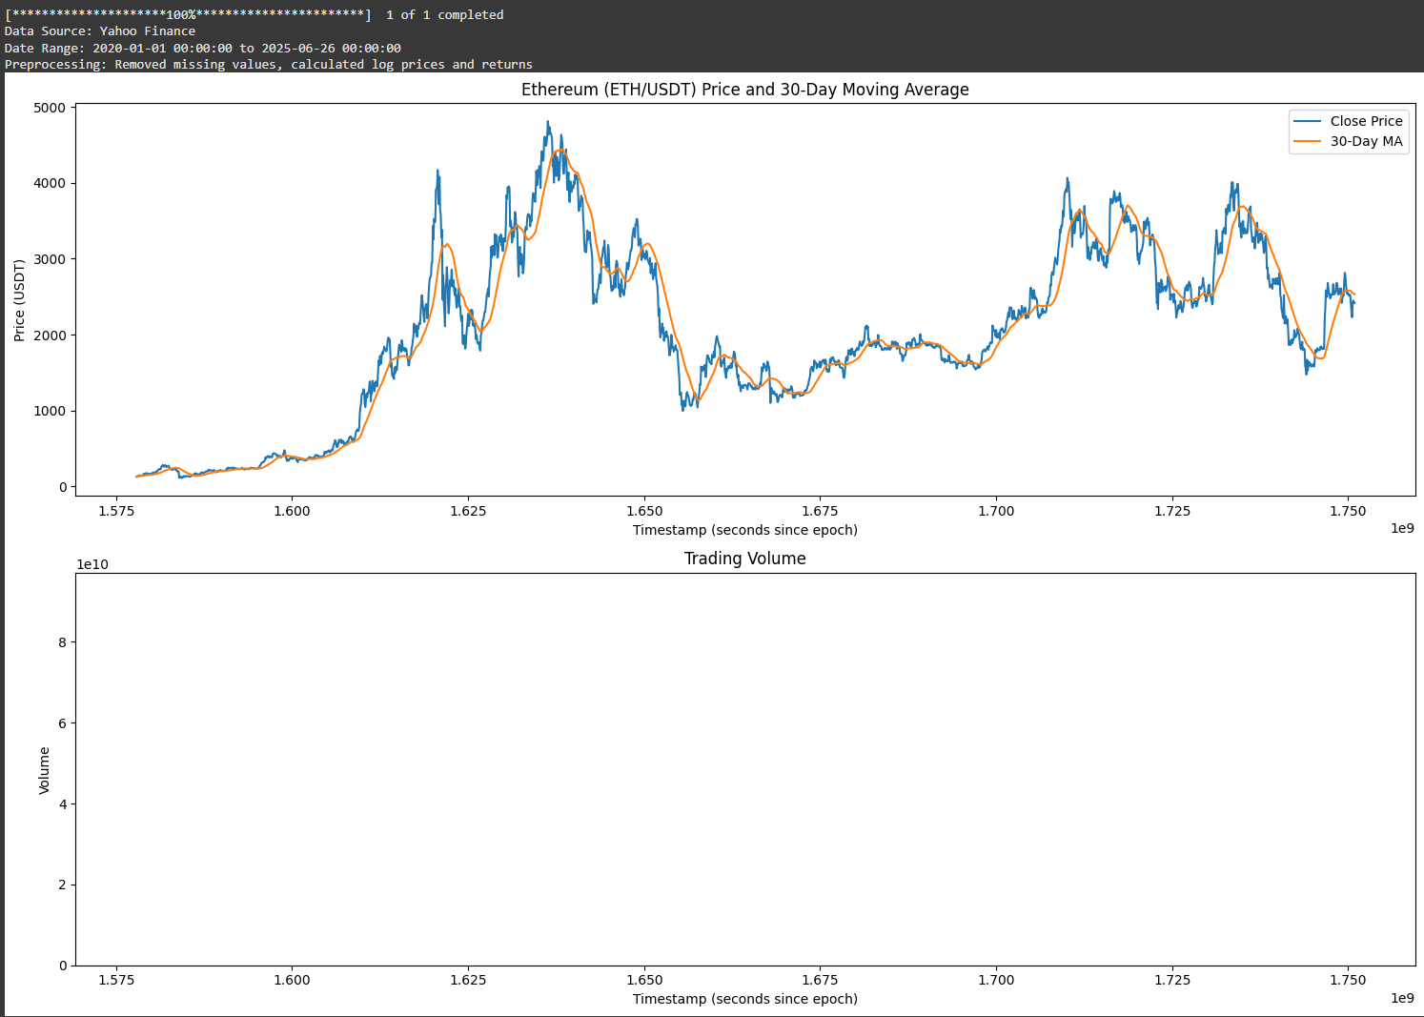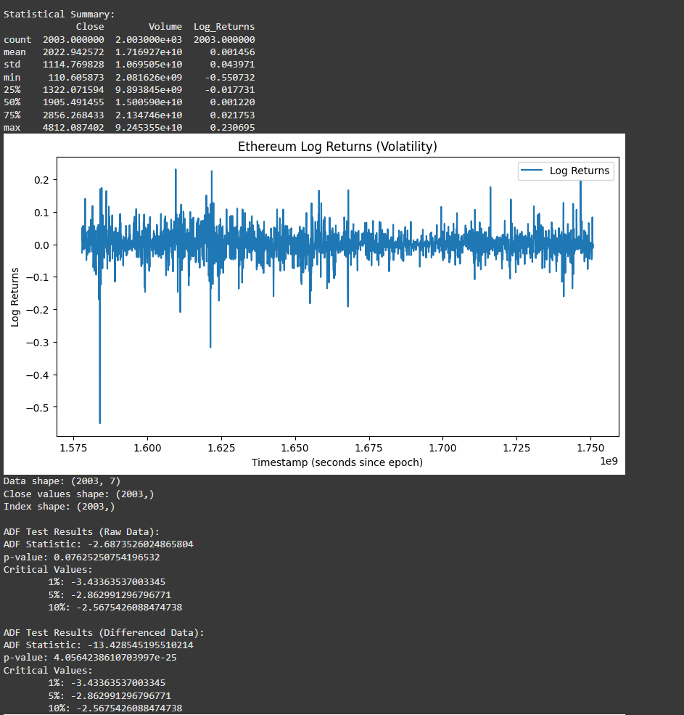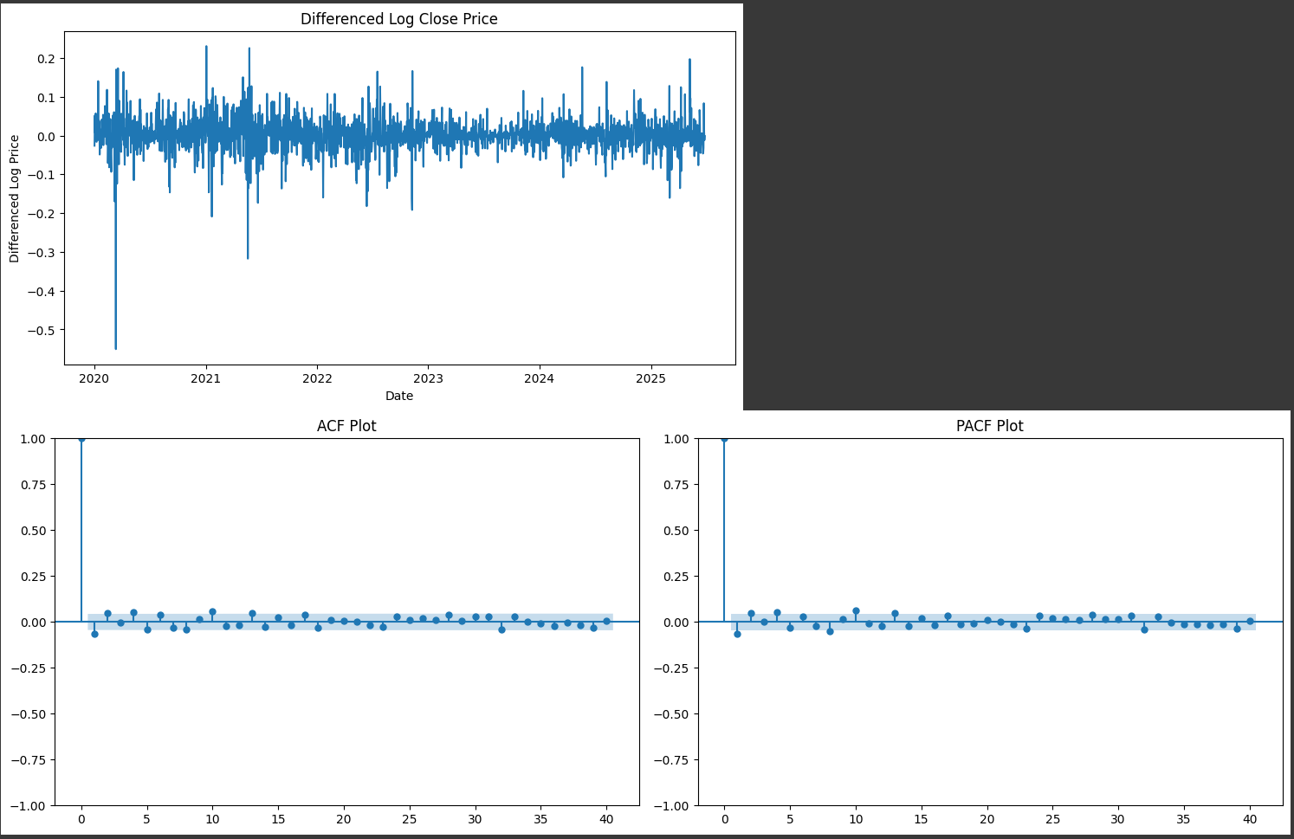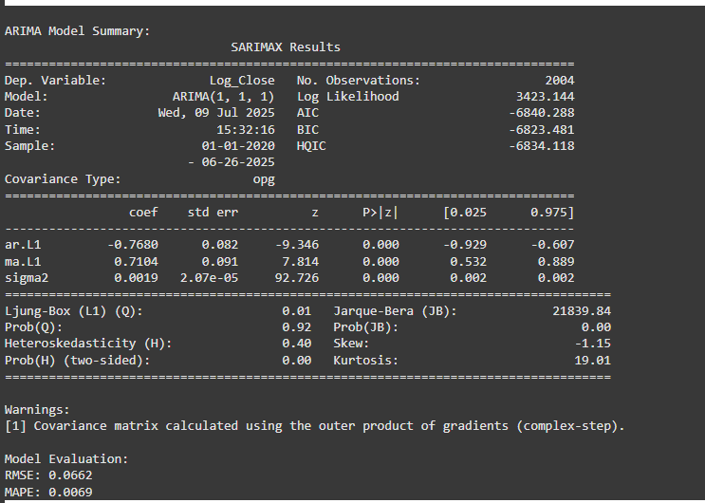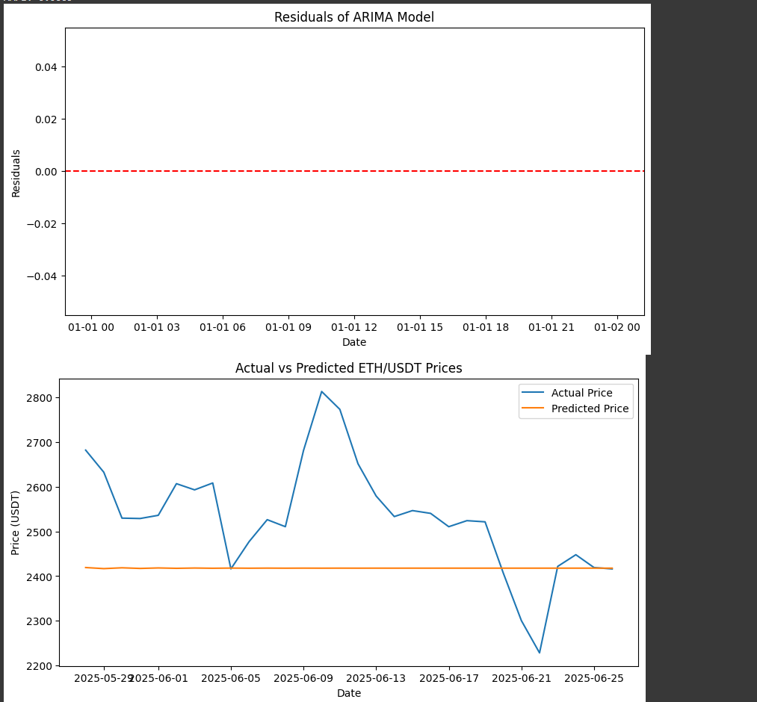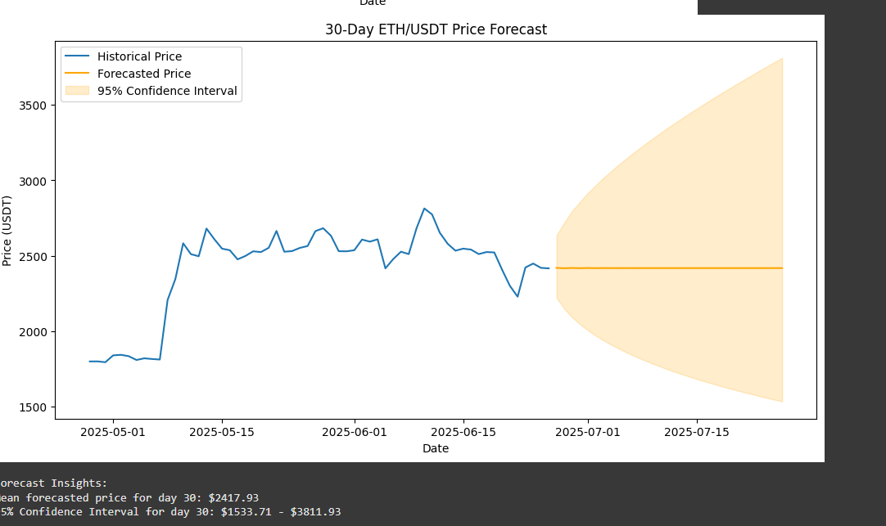

Insights & Conclusion
- ARIMA, despite its simplicity, can offer useful predictive insights for Ethereum price trends over short windows.
- However, crypto markets are highly volatile, and ARIMA's assumption of linearity limits long-term accuracy.
- Future improvement could include:
  - Integrating LSTM/GRU (deep learning) models.
  - Using external features (e.g., macroeconomic indicators, BTC prices, social media sentiment).
  - Implementing rolling forecast windows for continual updates.

